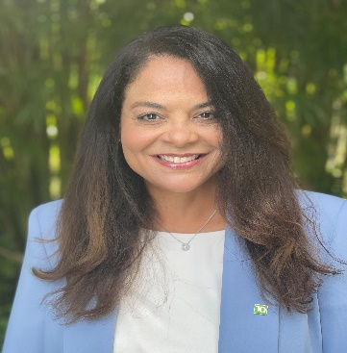

Licenia Rojas
SVP, Chief Engineer and Chief Architect

Licenia Rojas is a Senior Vice President, and Chief Engineer and Chief Architect at TD Bank. She is a solutions-driven, established Senior Technology Executive with a wealth of experience in planning, development and implementation of innovative technology solutions. Licenia has in-depth expertise in evolving technology platforms to support servicing functions, robotic process automation initiatives, and integrating machine learning and other artificial intelligence capabilities into legacy operations.

In her role, Licenia's mandate is to build world-class engineering capabilities to support the Bank and better serve our colleagues and our customers. This entails elevating the voice, expertise and execution of engineering across TD to improve the safety and stability of our systems, attract and develop talent and standards, and to enhance tooling and processes to support our architecture and engineering practitioners.

Licenia is a proud advocate for women in technology and recently participated as a keynote speaker at the Girls in Tech Conference to inspire and share insights on how to be your authentic self in the workplace. Licenia is a Board of Governor Member of the Alan B. Levan Nova Southeastern University Broward Center of Innovation. She also serves as Co-chair of the Year Up National Technology Advisory Council sub-committee for Financial Services and previously from 2016-2020 was a local advisory board member of Year Up South Florida.
Prior to joining TD, Licenia was at American Express for 23 years where she held several senior leadership roles, driving significant contributions to innovation, leading enterprise-wide data and digital capabilities. Most recently, she was the Senior Vice President and Unit CIO, Global Servicing Group Technology where she had global responsibility for the technology vision, strategy and delivery of the technology platforms that enable the best customer and colleague experience at American Express including all global servicing functions such as customer service, credit/collections, card issuance, procurement and real estate.
Licenia holds a Bachelor of Science in Management Information Systems from Barry University. She lives in Davie, FL with her husband Tony and 3 children.

